Representation of Data
Student ID ________________________
Student Name ________________________
Start Time ________________________
Finish Time ________________________

- Encode two float-point numbers step by step (1) 57.89 (2) -57.89

(1) 57.89 = 111001.1110001111010111₂ = 1. 110011110001111010111 x 2⁵
M = 1. 110011110001111010111₂
Fraction = 1100 1111 0001 1110 1011 100₂ 隐藏高位，尾数补0
E = 5
Bias = 127
Exponent= 132 = 10000100₂

Hex = 4 2 6 7 8 F 5 C
Binary = 0100 0010 0110 0111 1000 1111 0101 1100

(2) Hex = C 2 6 7 8 F 5 C
Binary = 1100 0010 0110 0111 1000 1111 0101 1100

2. data lab

Follow the instruction (Data_Lab.html) in dlab-handout. Write down your source code and show your screenshot of testing result. The following is mine, BTW.
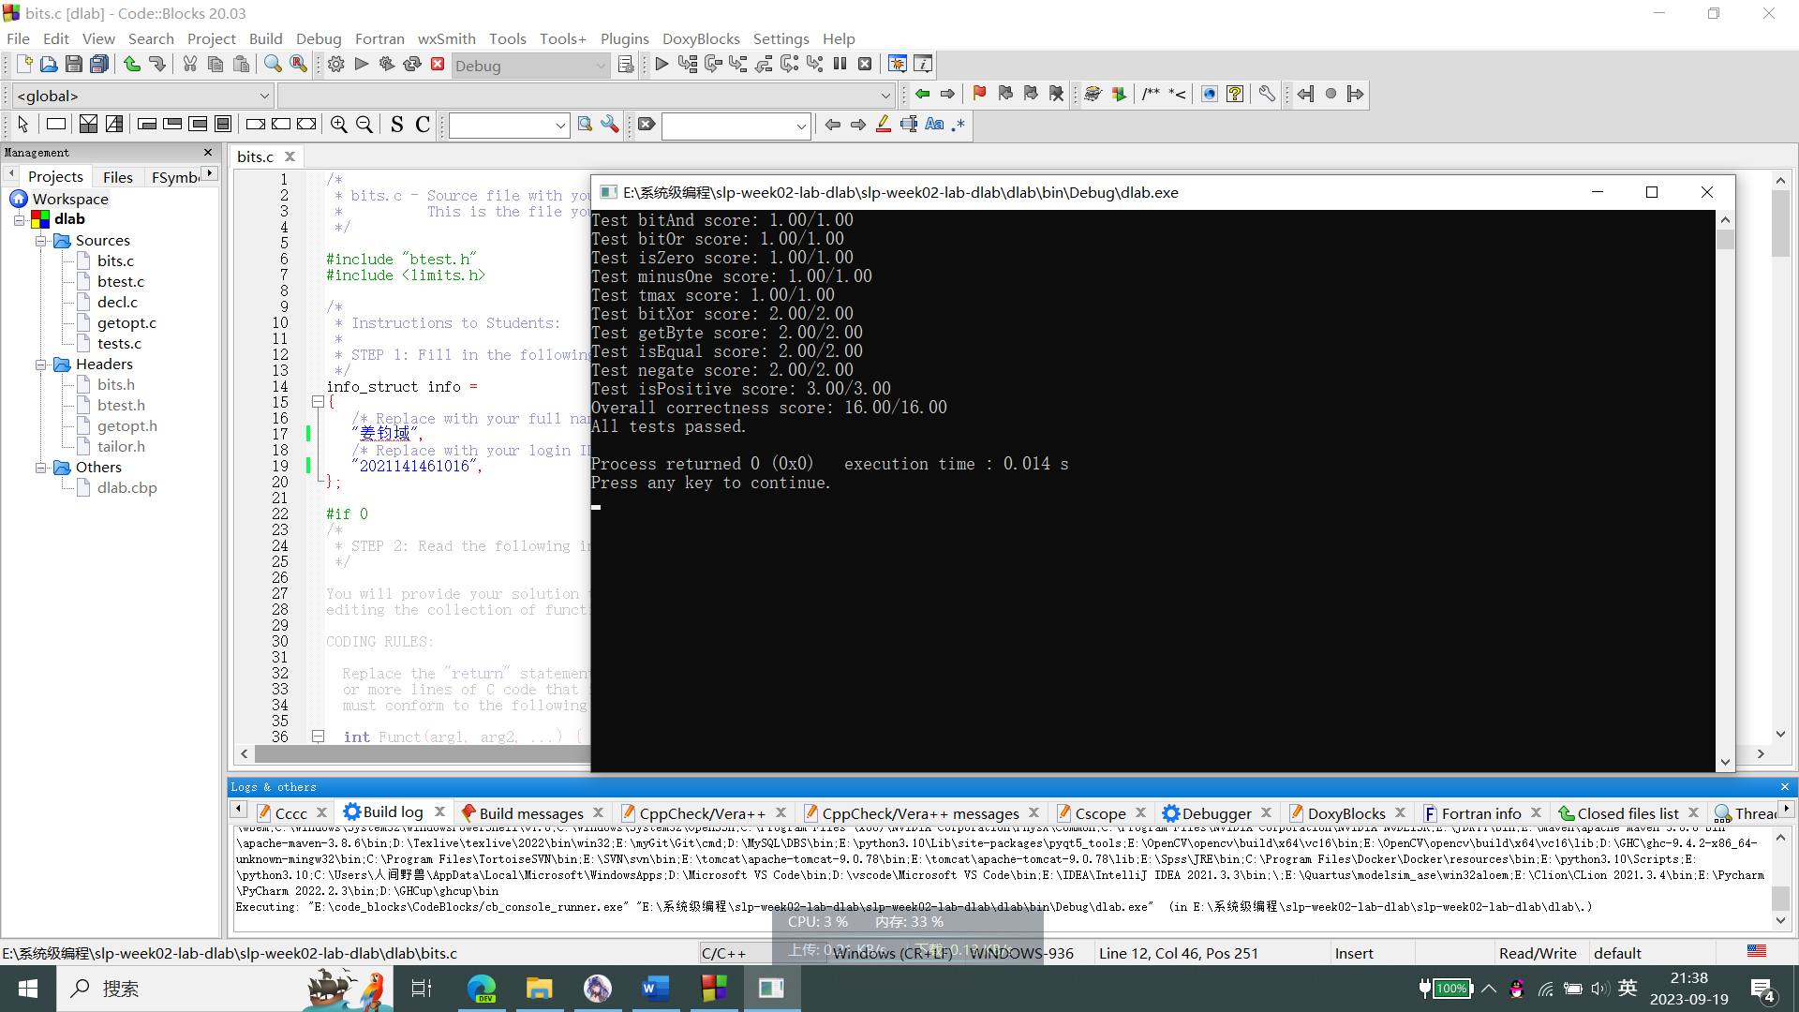

2.1
int bitAnd(int x, int y) {
int z = ~x|~y;
return ~z;

}

2.2
int bitOr(int x, int y) {
int z = ~x&~y;
return ~z;

}

2.3
int isZero(int x) {
return !x;

}

2.4
int minusOne(void) {
return ~0;

}

2.5
int tmax(void) {
int x = ~0;
x &= ~(1<<31);
return x;

}

2.6
int bitXor(int x, int y) {

return (~x&y)|(x&~y);
}

2.7
int getByte(int x, int n) {
int shiftNum = n<<3;
int result = x&(255<<shiftNum);
return (result>>shiftNum)&255;
}

2.8
int isEqual(int x, int y) {
return !(~((~x & ~y) | (x & y)));

}

2.9
int negate(int x) {
return ~x+1;

}

2.10
int isPositive(int x) {

int sign = (x&(1<<31))>>31;
return ((~sign)&1)&~(!x);

}

